SnapApp

Ayush Singhal (181500181)

Aditya Pratap Singh (181500045)



A Social Media Application

**Problem Statement**

This project is about a social media platform where users can share their daily life activities with everyone there through images. User can add description about their posts. The other users can like their posts if they like it. The features we provided are Like, Update, Delete a post. Also, there are two options for user to signup: one is using Google Log In, other is using your own Email Id.

**Reason for Selecting the Topic**

The reason for selecting this topic was provide an easy-to-use social media platform for people to interact with each other. All age group people will use our platform easily as our platform will be less complicated and accessible for everyone.

**Objective of the Project**

Through SnapApp, we want to give people a simple social media platform which is easily accessible by people of different age groups and where they can share their real-life activities and experiences through snaps and images to everyone there and they can used it as to store their memories for future. People on our platform can connect with each other and share their opinions on others post.

**Contribution of the Project**

Our project will highly beneficial to the people who likes a simple platform to interact with the world, a platform which is less complicated and easy-to-use for them.

**Feasibility Study**

Talking about the feasibility of this project, in the current scenario, there are not many social media platforms out there which are less complicated and easy to use for the people of all age groups.

Other supporting reason is the amount of people who interacted to the others through social media platforms.

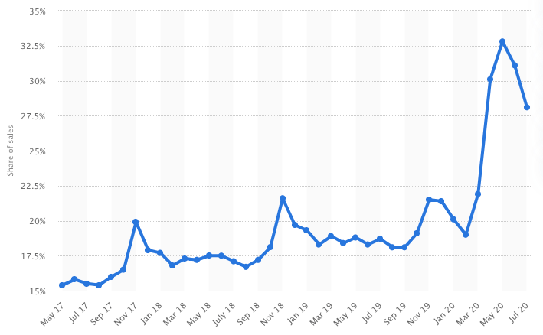The graph below shows the increase in online users from 2017-2020:

Online User

**Methodology**

In this project, we will use Front End Technologies like HTML, CSS, JavaScript (using React.js) to design our website. We will keep our website design responsive so that it will work smoothly on all gadgets. We will also use some creative software like Adobe Photoshop, Adobe Illustrator to design the logo and make images of items to be displayed clear.

For Back End technologies like Express.js and Node.js for communication with database and server and MongoDB for storing the data into the database will be used.

So, in summary we will use Full Stack for the development of our project.

**Scope for Extension into a Major Project**

**Our project has a great scope for extension into a major project. We will provide multiple features for users like Comment feature, where users can comment on the post; Friend List, where a user can add other users as his/her friend and will share posts with them; Inbox Chat, where user can chat with other users and many more.**

**Future Scope**

For the future, we intend to cover more people with our application and will update out application according to future needs.

**Hardware and Software to be Used**

**HARDWARE:**

1. Laptop or PC with the following configuration (minimum, for decent execution):
   * **Processor**: Intel Core i3 6th Generation
   * **Ram**: 4GB
   * **OS**: Microsoft Windows 7 or above

**SOFTWARE:**

1. **GitHub**: For hosting the website (At the initial stage) and to store the website design and related stuff.
2. **Front End Technologies**:
   1. HTML5
   2. CSS 3
   3. JavaScript using React.js
3. **Back End Technologies**:
   1. MongoDB – document database
   2. Express.js – server-side web framework
   3. Node.js – premier JavaScript web server

**Testing Technologies to be Used**

**HARDWARE:**

1. Desktop
2. Laptop
3. Tablet
4. Cellphone

**SOFTWARE:**

1. Browsers (for compatibility check):
   1. Google Chrome
   2. Mozilla Firefox
   3. Microsoft Internet Explorer
   4. Microsoft Edge
   5. Apple Safari
2. Search Engines

**References / Bibliography**

1. Google
2. Wikipedia
3. Tutorial sites
4. Bing images